**Graphic Designers Hub**

Project Members: -

1. **Rohan Mahendra Mandavkar 210943120080**
2. **Abhishek Suresh Kidye 210943120004**
3. **Pushkar Gulabrao Sabe 210943120077**

1. Introduction: -

In today’s world of growing business and entrepreneurship, everyone needs a graphic designer, but approaching a graphic appropriate graphic designer was not that easy as there is no such valid platform. By this project we will create one platform where designers and clients will meet. Designers can show their work and increase their business by marketing on this website. Project will contain various sections like logo, banners etc. and accordingly, designers will be sorted. The related information will be stored in database. Proper validations will be provided for the forms.

The project will also reduce the customers efforts to search a desirable and affordable graphic designer for his business.

* 1. Problem definition:

There is no such website where all the designers are found at one place which makes it difficult for customer/client to search and sort the designer according to his requirement.

* 1. Objective and Scope of Project:

The objective of project is to reduce marketing efforts of graphic designers by providing this platform. Also, time and efforts of clients are reduced as they can find designer according to their requirements at one place and also can have choice among number of designers and can filter them according to their prices.

1. Feasibility Study: -

This project focuses on the graphic designers and customer interaction. This enables the graphic designers to host their business over a online platform which was not possible till now. This also facilitates the customer to interact and find his dream designer according to his/her needs. He/she can also compare the costing, rating, experience by actually visiting the designer’s profile.

1. Analysis: -

* 1. Existing System:

There was no such existing system to work on this topic.

* 1. Proposed System:
* Number of designers will be available at one place.
* Searching and communicating efforts of both clients and graphic designers are reduced.
* Various sections of graphic designing will be available for easy search (eg: Logo, banners, art, posters, typography, digital art, etc.)
* Client can see the work of designers on their profile and then can choose best designer according to his/her need.
* Client can easily have budget friendly graphic designer for his work as filter option is available.
* Client can give reviews on the designer’s work.

* 1. Hardware and Software Requirements (Minimum):

**Hardware:**

1. Intel i3 processor 3rd generation or later / AMD Ryzen 200 2nd generation or later

2. 4 GB ddr3 ram.

3. Windows 7 Home edition or later.

4. 200 GB Sata HDD Space

5. Data Connection 200 kbps

**Software:**

1. VSCode
2. MongoDB Compass
3. ReactJS
4. NodeJS
5. Google Chrome Browser
6. Design: -
   1. Data Flow Diagram (DFD):

Level 0:

Admin management

Order management

Graphic designer’s hub

Designer management

Login management

Fig.1. Level 0 DFD

Data Flow Diagram (DFD):

Level 1:

Manages

Login

Designers

Admin

Manages

Login

Customer

Gives

Feedback

Orders products

Order product

Fig.2. Level 1 DFD

Data Flow Diagram (DFD):

Level 2: Admin DFD

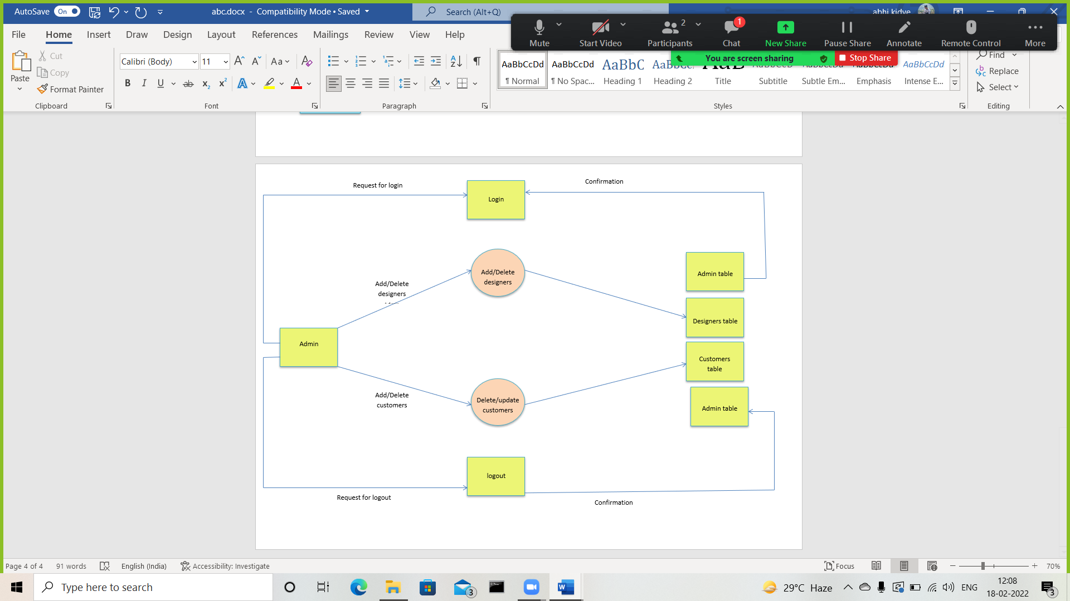

Fig.3. Level 2 DFD

Designer DFD

Request for Login

Store/Update order

Store/Update order

Confirmation

Confirmation

Request for Logout

Delete order

Receives order

Designer

Logout

Order Table

Login

Designer Table

Add

order

Designer Table

Delete

order

Fig.4. Designer DFD

ER Diagram: -

Qualification

UserName

aID

Password

gID

Password

UserName

Manages

EmailID

Admin

1

1

M

1

M

M

M

1

Gives

CustomerId

DesignerId

fID

Review

Feedback/Review

Accepts

OrderTable

Identity_Proof

Place

DurationDuration

Description

OrderType

gID

cID

oID

OrganizationName

Address

PhoneNumber

EmailID

Password

UserName

cID

User

Identity_Proof

PhoneNumber

Address

Designer

Phone

Email

1. Implementation: -
   1. Modules

We basically have 3 different modules in our project namely:

* Designer
* Order
* User
  1. Modules Description: -

1. Designer: -

* Designer is the one who is the core part of the project.
* He creates his account, login and hosts his work on the site so that users(clients) can see that.
* He has his own reviews, experience and ratings (given by user) on which he is classified.
* There are also various types of designers viz typography, logo designers, calligraphy designers etc.

1. User:-

* User is the entity who can create an account and login and access the designers and choose his desired designer according to his needs and the ratings and experience.
* User can give ratings and reviews to designer.
* He also has facility to reset password where recovery mail will be sent to his email.

1. Order: -

* Order is the module in which the user place order and designer accepts the order.
* The respective data is stored in order table from which designer and user both can access their respective data.
  1. Implementation Technologies:

1. NodeJS:

# NodeJS is primarily developed in JavaScript, CoffeeScript, and C++. NodeJS is an asynchronous, event-driven JavaScript runtime environment that can run JavaScript code outside the web browser. NodeJS is built on JavaScript, so it is extremely lightweight and unbelievably efficient.

# NodeJS is a perfect choice when your application requires to deal with complex and intensive data processing. NodeJS can process complex data with ease and that’s why a lot of apps that require intensive data processing use NodeJS. That’s why people hire NodeJS Developers to build their apps.

Features of NodeJS:

# As NodeJS is a runtime environment of JavaScript, NodeJS applications are lightweight and faster as compared to the traditional applications that take a lot of time to load and process data. So, it is a JavaScript boon that your applications are lightweight and lightning-fast in processing the data.

# When your application requires efficient I/O tasks, you can choose NodeJS without giving it a second thought. NodeJS Applications are a great fit when your applications process a lot of Input and Output tasks. For example, an application that takes frequent inputs from the users.

# NodeJS applications consume much lower memory than traditional mobile apps. When your app is built with NodeJS, you can save a lot of memory on your device as NodeJS applications can run even in memory shortage, so it won’t be hard for your device to run the applications built with NodeJS.

# Another big advantage of choosing NodeJS is its Node Package Manager, also known as the NPM. The Node Package Manager is constantly growing and more and more features are being available with the constantly growing Node Package Manager. You can’t deny the fact that the NPM is one big reason to choose NodeJS development for your next business application

1. ReactJS

React JS is basically a JavaScript library built and maintained by Facebook. According to the creator of React JS, Jordan Walke, React is an efficient, declarative, and flexible open-source JavaScript library for building simple, fast, and scalable frontends of web applications.

### **Speed**

The React basically allows developers to utilize individual parts of their application on both client-side and the server-side, which ultimately boosts the speed of the development process

### **Flexibility**

Compared to other frontend frameworks, the React code is easier to maintain and is flexible due to its modular structure. This flexibility, in turn, saves huge amount of time and cost to businesses.

### **Flexibility**

Compared to other frontend frameworks, the React code is easier to maintain and is flexible due to its modular structure. This flexibility, in turn, saves huge amount of time and cost to businesses

### **Performance**

React JS was designed to provide high performance in mind. The core of the framework offers a virtual DOM program and server-side rendering, which makes complex apps run extremely fast.

### **Reusable Components**

one of the main benefits of using React JS is its potential to reuse components. It saves time for developers as they don’t have to write various codes for the same features. Furthermore, if any changes are made in any particular part, it will not affect other parts of the application.

1. **MongoDB**

As a definition, MongoDB is an open-source database that uses a document-oriented data model and a non-structured query language. It is one of the most powerful NoSQL systems and databases around, today.

Being a NoSQL tool means that it does not use the usual rows and columns that you so much associate with relational database management. It is an architecture that is built on collections and documents. The basic unit of data in this database consists of a set of key-value pairs. It allows documents to have different fields and structures. This database uses a document storage format called BSON which is a binary style of JSON documents.

**Features of MongoDB:**

**Schema-less Database:**It is the great feature provided by the MongoDB. A Schema-less database means one collection can hold different types of documents in it. Or in other words, in the MongoDB database, a single collection can hold multiple documents and these documents may consist of the different numbers of fields, content, and size. It is not necessary that the one document is similar to another document like in the relational databases. Due to this cool feature, MongoDB provides great flexibility to databases.

**Document Oriented:**In MongoDB, all the data stored in the documents instead of tables like in RDBMS. In these documents, the data is stored in fields (key-value pair) instead of rows and columns which make the data much more flexible in comparison to RDBMS. And each document contains its unique object id.

**Indexing:**In MongoDB database, every field in the documents is indexed with primary and secondary indices this makes easier and takes less time to get or search data from the pool of the data. If the data is not indexed, then database search each document with the specified query which takes lots of time and not so efficient.

**Scalability:**MongoDB provides horizontal scalability with the help of sharding. Sharding means to distribute data on multiple servers, here a large amount of data is partitioned into data chunks using the shard key, and these data chunks are evenly distributed across shards that reside across many physical servers. It will also add new machines to a running database.

**Replication:**MongoDB provides high availability and redundancy with the help of replication, it creates multiple copies of the data and sends these copies to a different server so that if one server fails, then the data is retrieved from another server.

**Aggregation:**It allows to perform operations on the grouped data and get a single result or computed result. It is similar to the SQL GROUPBY clause. It provides three different aggregations i.e, aggregation pipeline, map-reduce function, and single-purpose aggregation methods

**High Performance:**The performance of MongoDB is very high and data persistence as compared to another database due to its features like scalability, indexing, replication, etc.

**Advantages of MongoDB**

MongoDB is very flexible and adaptable to real business world situations and requirements.

* Queries can be made to return certain fields within documents.
* MongoDB supports field, range-based query, regular expression, etc. for searching the data from the stored data.
* MongoDB is a very easy DBMS system that can easily scale up or down.
* MongoDB helps you to uses internal memory for storing the working temporary datasets for which it is much faster.
* MongoDB offers primary and secondary indexes on any field.
* MongoDB supports the replication of the database.
* You can use MongoDB as a file storage system which is known as a GridFS.
* MongoDB offers various methods to perform aggregation operations on the data like aggregation pipeline, map-reduce or single objective aggregation commands.
* MongoDB allows you to store any type of file which can be any size without effecting our stack
* MongoDB basically uses JavaScript objects in place of the procedure.
* MongoDB supports special collection type like TTL (Time-To-Live) for data storage which will expire at a certain time
* The dynamic database schema used in MongoDB is called the JSON
* Indexes can be created to improve the performance of searches within MongoDB. Any field in a MongoDB document can be indexed.
* Replication – MongoDB can provide high availability with replica sets
* MongoDB can run over multiple servers, balancing the load and/or duplicating data to keep the system up and running in case of hardware failure.

1. Test cases: -

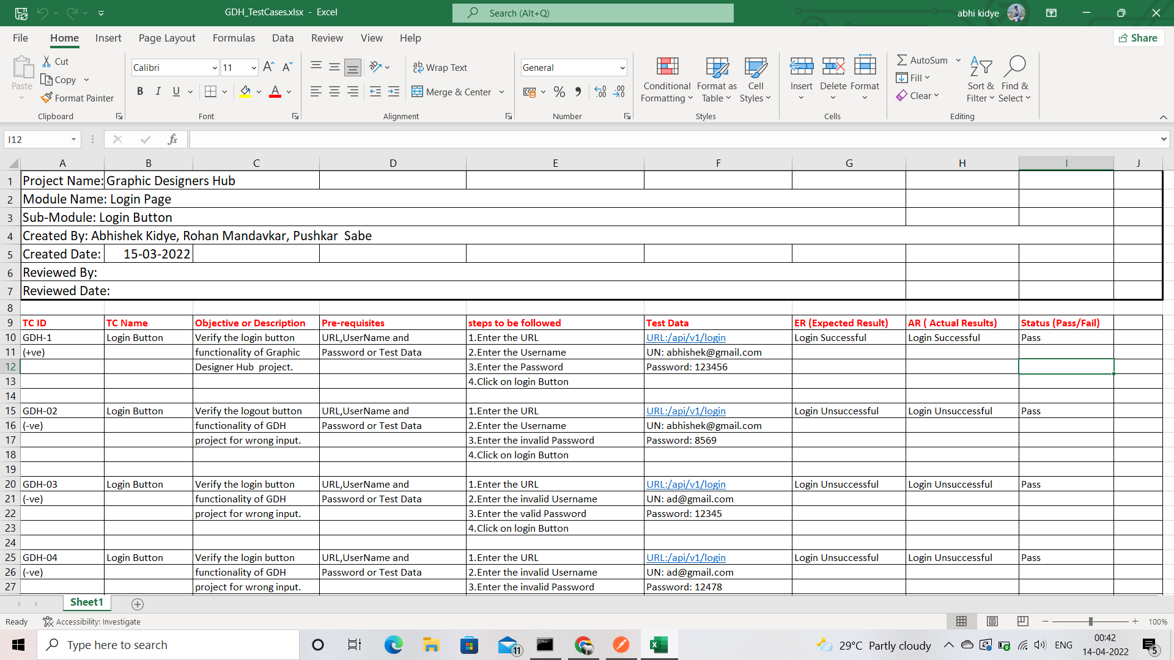

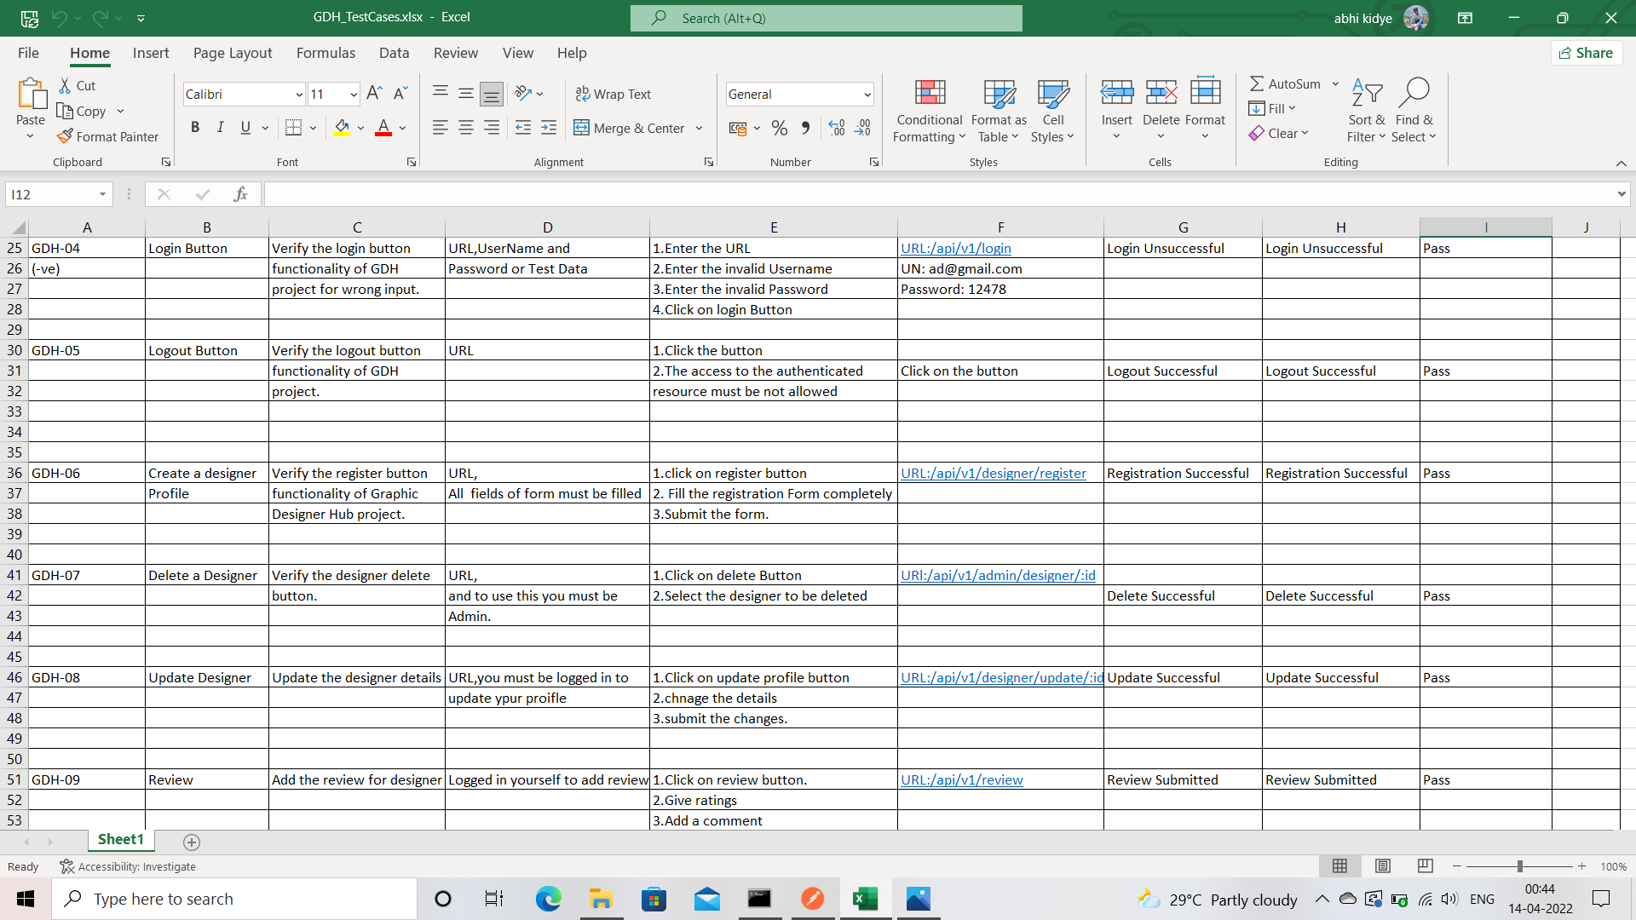

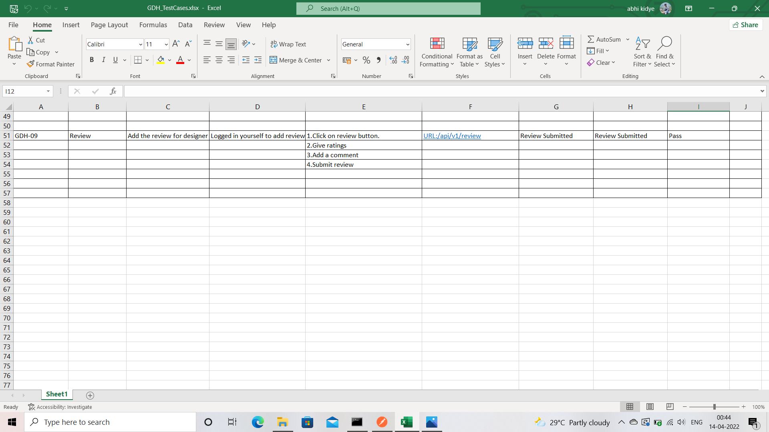

1. Screenshots of Webpages: -

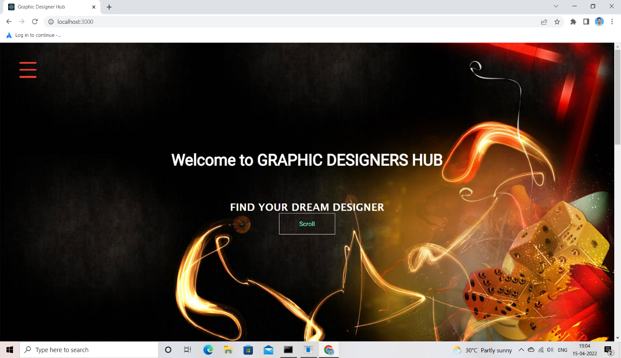

Image1- Home Page

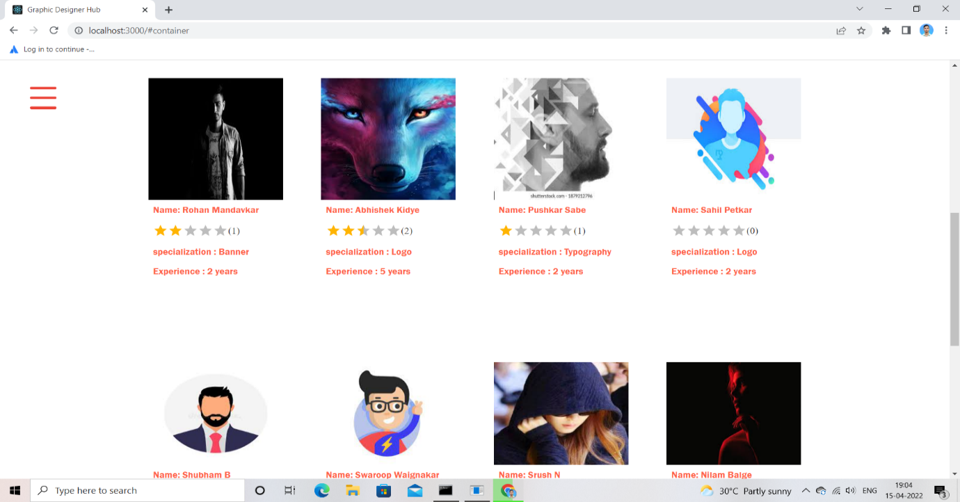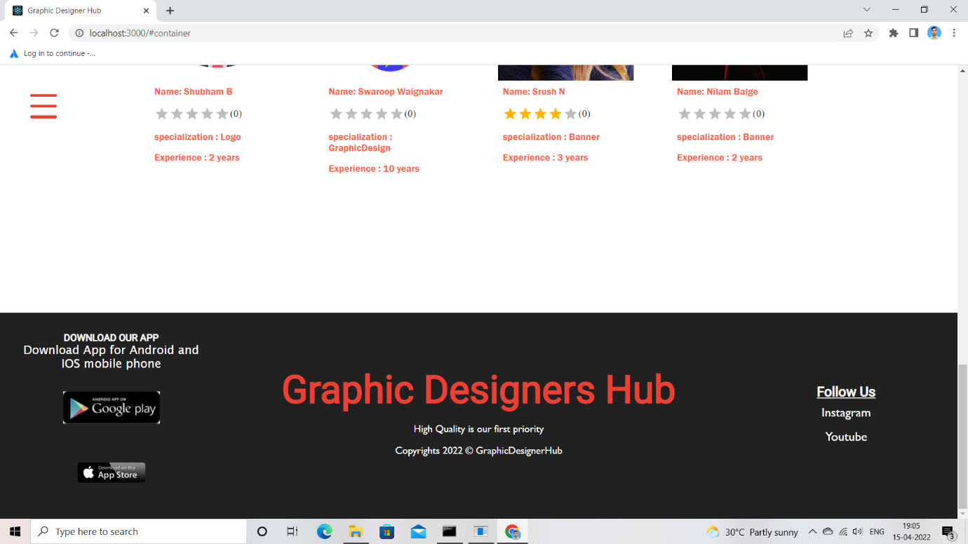

Image2- Designers Page

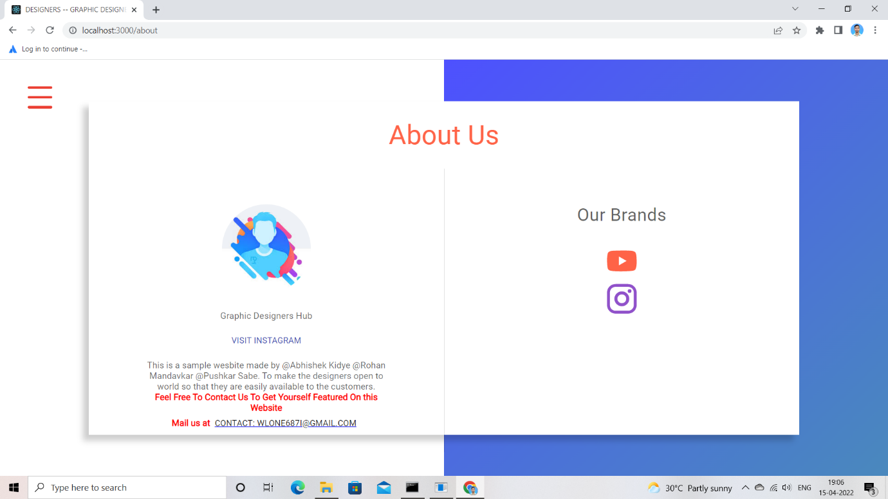

Image3- About Us Page

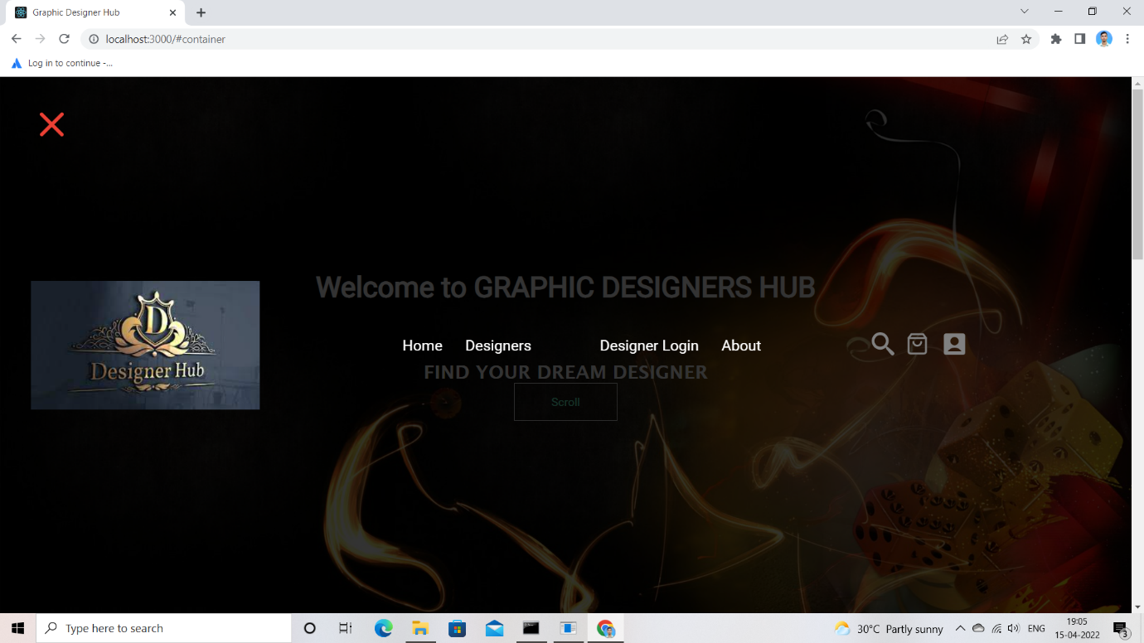

Image4- Navigation Bar

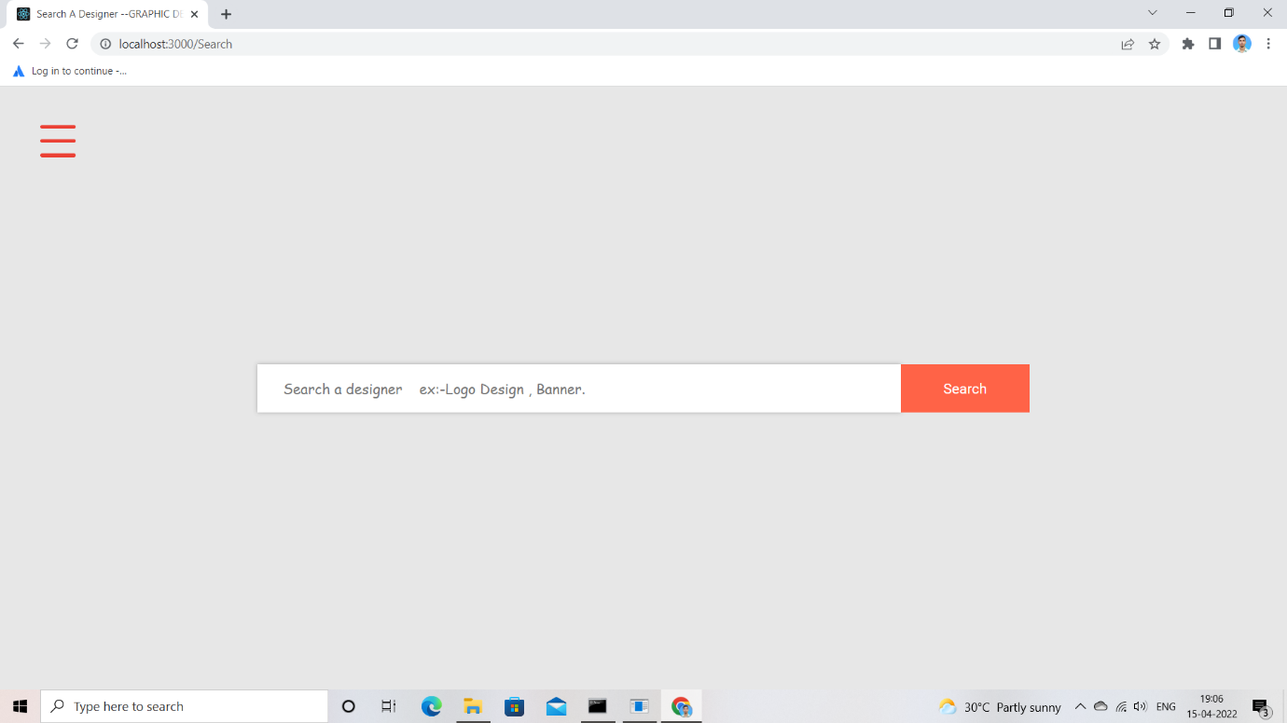

Image5- Search Page

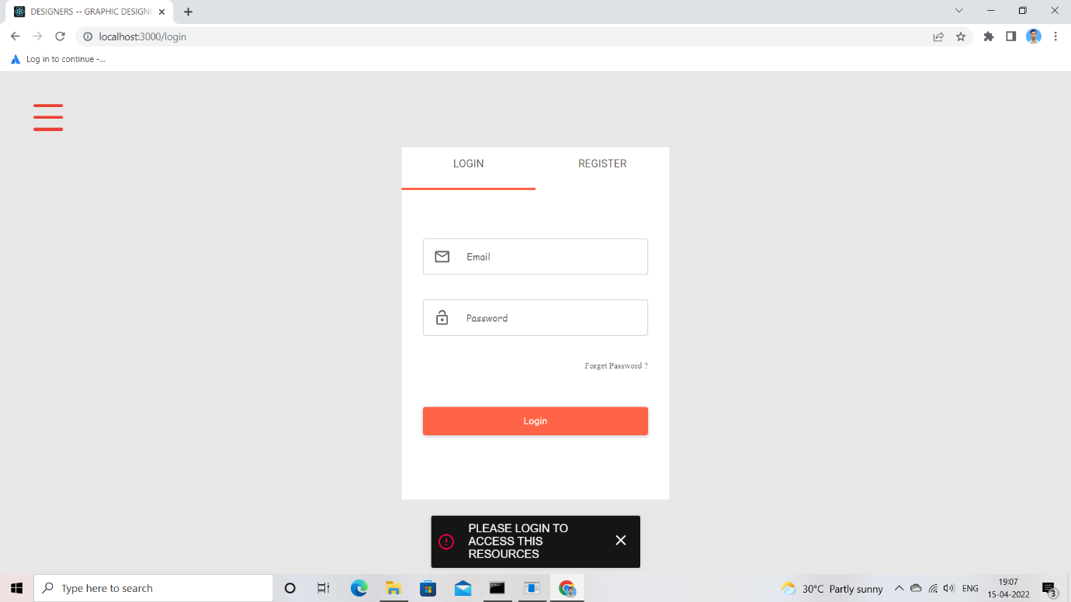

Image6- Login Page

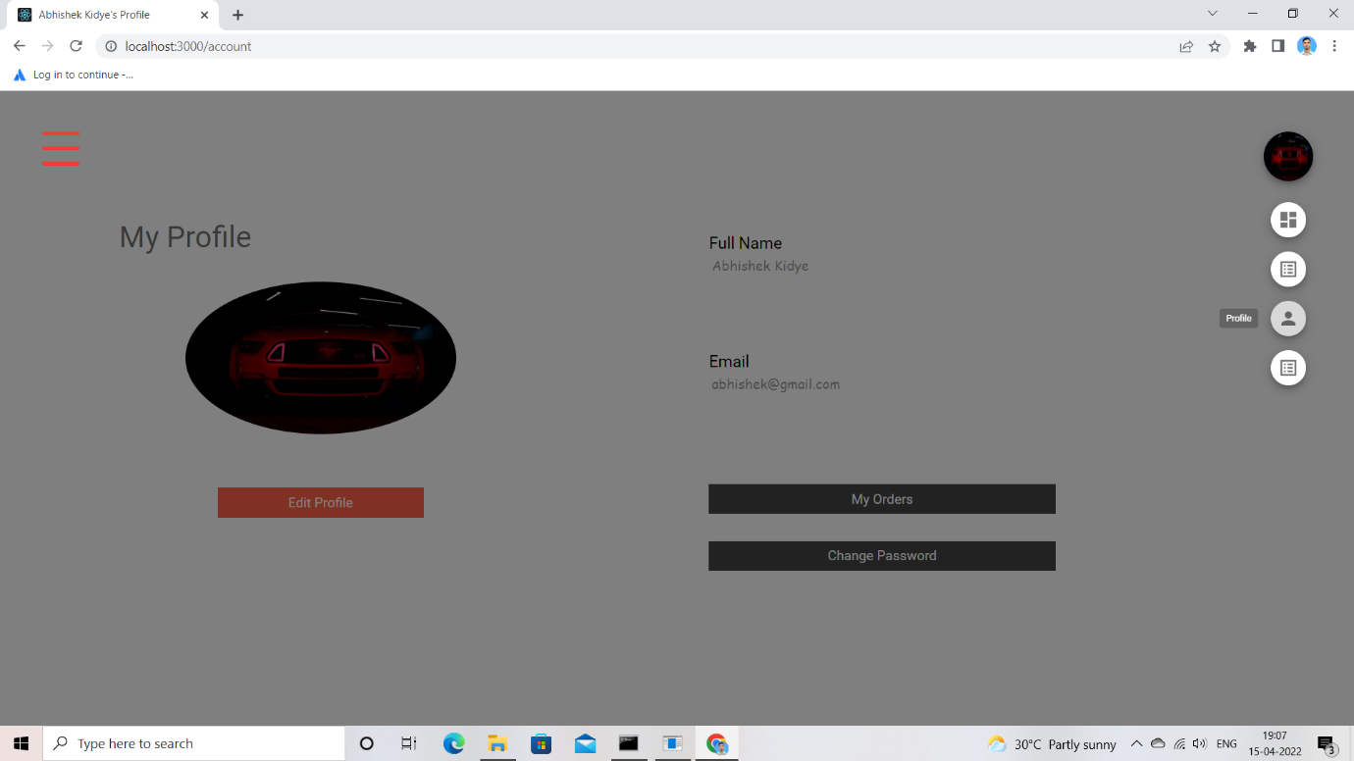

Image7- Profile Page

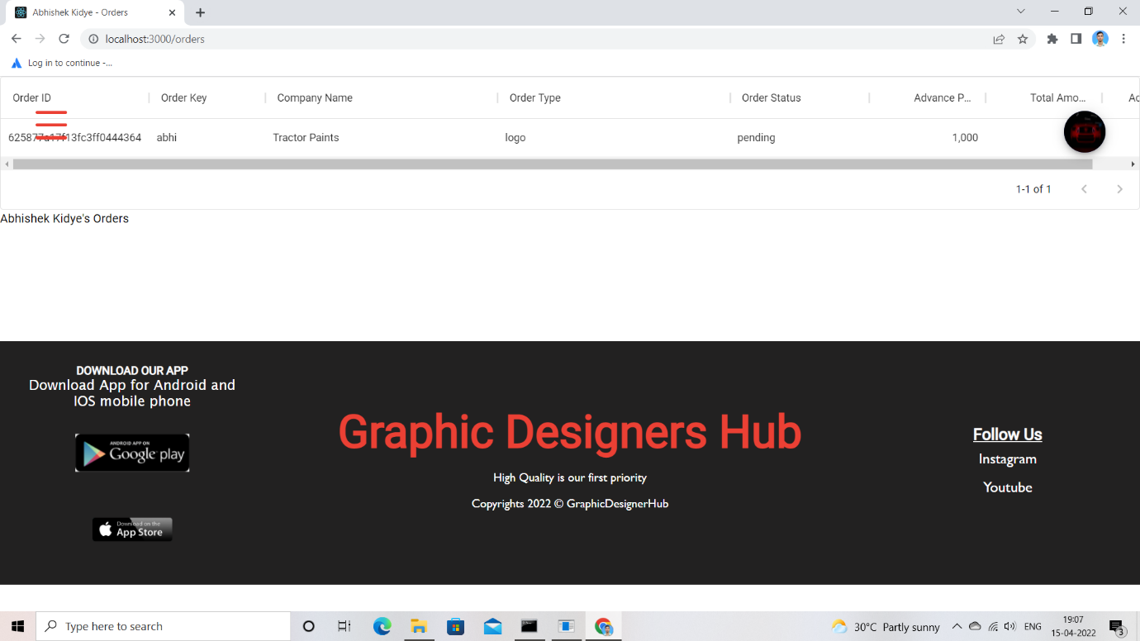

Image8- My Orders Page

1. Conclusion: -

After implementation of this project, it will be easy for designers to interact with their customers. Also the customer will find it easy to find a designer of his/her choice and need. This can enhance a designers business.

1. Future Scope:
2. We can let the other website owner to let us promote their work if they are unable to reach the consumers. And we will make sure that the world sees their projects and buys them.
3. Some designers and artists also make some random digital arts or normal sketch etc. we can make a platform for them to sell their artwork at fair price in future.
4. Anyone can use this platform to sell their Artworks in future.
5. We can provide basic templates, so that people who wish to prepare logo or pamphlet which is not for a very important purpose can use these basic themes and design their artwork on their own.
6. Bibliography: -

Sites referred: -1. W3Schools tutorials (website)2. React official website: - https://reactjs.org/tutorial/tutorial.html3. 6 pack programmer

4. https://www.npmjs.com/package/@material-ui/iconsFaculty: -1. Mrs. Harshita Maheshwari madam2. Mr. Saleel Bagade